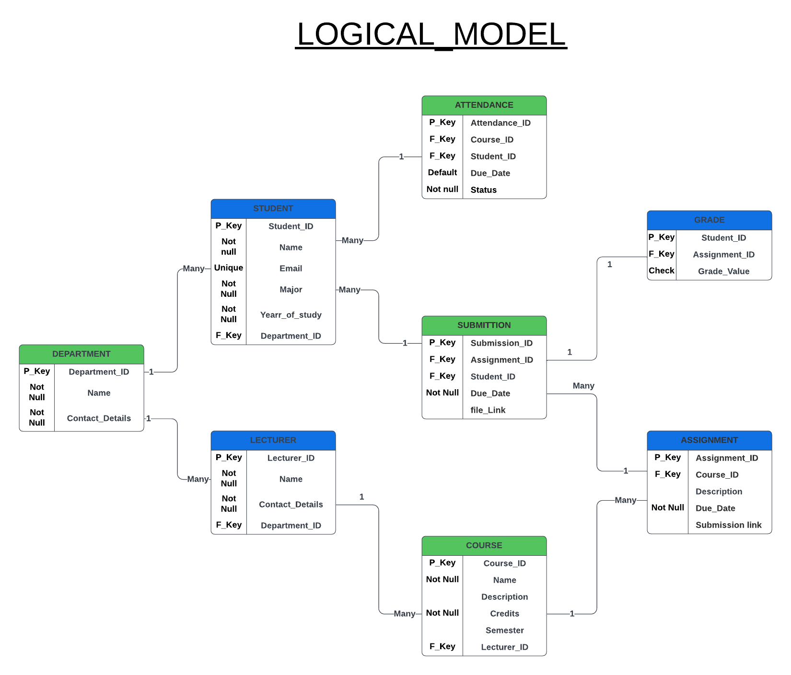

**DETAILS**

The logical model diagram represents a structured database design for a course management system. It defines the main entities, attributes, primary keys, foreign keys, and relationships that support streamlined management of students, lecturers, courses, assignments, attendance, submissions, grades, and departments. Here’s a summary of the primary entities and their connections:

**Department:** Contains details about university departments (e.g., ID, name, and contact details) and relates to both lecturers and students, as each belongs to a specific department (one-to-many relationships with both lecturers and students).

**Lecturer:** Stores information about lecturers (e.g., ID, name, and contact details) and is linked to a department and the courses they teach. Each lecturer can teach multiple courses, but each course is assigned to one lecturer.

**Course:** Includes course details (e.g., ID, name, description, credits, and semester). It connects to a lecturer (one-to-many) and has multiple assignments and attendance records associated with it.

**Student:** Holds student data (e.g., ID, name, email, major, year of study) and is linked to a department. Students participate in courses and have attendance records, assignments, and grades.

**Assignment:** Manages information about assignments (e.g., ID, course link, description, due date, submission link). It is linked to a course and has multiple submissions from students.

**Submission:** Tracks student submissions for assignments, containing details like the submission ID, assignment link, student ID, due date, and file link. Each submission has an associated grade.

**Grade:** Records grades for each student’s submission for an assignment, holding values like student ID, assignment ID, and grade value. It supports progress tracking for each student.

**Attendance:** Logs attendance for students in courses, containing details like attendance ID, course ID, student ID, date, and status. It allows tracking of student participation across classes.